Family Math Kit: Measurement

What is in this Math Kit?

PIPE CLEANER RAINBOW
- Instructions
- Pipe Cleaners
- Play-Doh
- Tape Measure

MATH JOURNAL

Making the
PIPE CLEANER RAINBOW

Completing the
MATH JOURNAL

The materials are your child's to keep forever!

Please complete and return
the Math Journal to the teacher
by _________

Measure and line up the pipe cleaners from longest to shortest to create a colorful rainbow!

The Math Journal is where you share with the teacher about MATH at home, at work, and in the neighborhood.

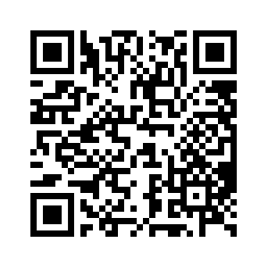
Did you know?

Scan this QR code to listen to a short audio about how to help young children learn about MEASUREMENT.

